

**Software Design and development project**

**Unit Coordinator:** Jamie Shield

**Tutor:** Dr.Zakiullah Khan

**Submitted by:** Bandana Kapali, 12127043

**Group Team member:**

Adarsha Mani Lamichhane, 12140071

Bandana Kapali, 12127043

Javagal Srinath Narayan, 12131231

Maruf Siddique, 12132167

# Project Brief

CQU lab management system is an application build for the staffs and student to quickly find lab equipment available in all the campuses. Lab management system offers a set of key features that will support a modern laboratory operation. The main aim of our application will be to eliminate the spreadsheet and paperwork and to organize and record all the lab equipment. CQU lab management system will set the key features that support a modern lab operation like data tracking support, flexible architecture and smart data exchange interfaces that will support its use in everyday regulated environment.

# Skill development plan

Our project is to make a mobile application and for that we need to have knowledge on Java programming language. Since I have completed a few subjects already in the same language I have a basic understanding for Java. However, I have yet to learn how to make mobile applications.

I have an ongoing course App Development for Mobile Platforms (COIT20270) this semester along with the Software Design and Development Project (COIT20273) which will be very beneficial for me to learn and apply what I have learnt in making our project. Our first goal will be to make a good user interface which consists of all the functional requirements the application should perform without it being too difficult to understand. I have been fascinated with the user interface and user experience of a certain application or a software can affect, how visual symmetry, colour, font, buttons, and pictures placements can have immense effect on how a user can unknowingly be attracted or unattracted towards the application. It being one of the crucial parts on the success of the project we have made it our priority to have it look and feel as flawless as possible.

# Project plan

## 2.1 Purpose for undertaking the project

The client is a lecturer at CQU university, and the client likes to have a Lab Equipment Sourcing for all students and staff to have easy access to all lab equipment’s available in the university. Currently the data has been saved in the spreadsheet that has many locations including ROK 28.G10.

Reasons for undertaking the project

* Ease of use
* To improve analysis
* Organise and record all the lab equipment
* Eliminate the spreadsheet and paperwork
* Develop database to record each and everything
* Keeping track of all students, staffs and lab equipment.

# Feasibility study

## 3.1 Economic Feasibility

* The cost of spending on the spreadsheet will be reduced once the application is deployed.
* Cost of advertising to the outer market will be reduced
* As the application automates the process which will helps reducing the human errors.

The figure shows the cost benefit analysis of the Lab equipment sourcing app:

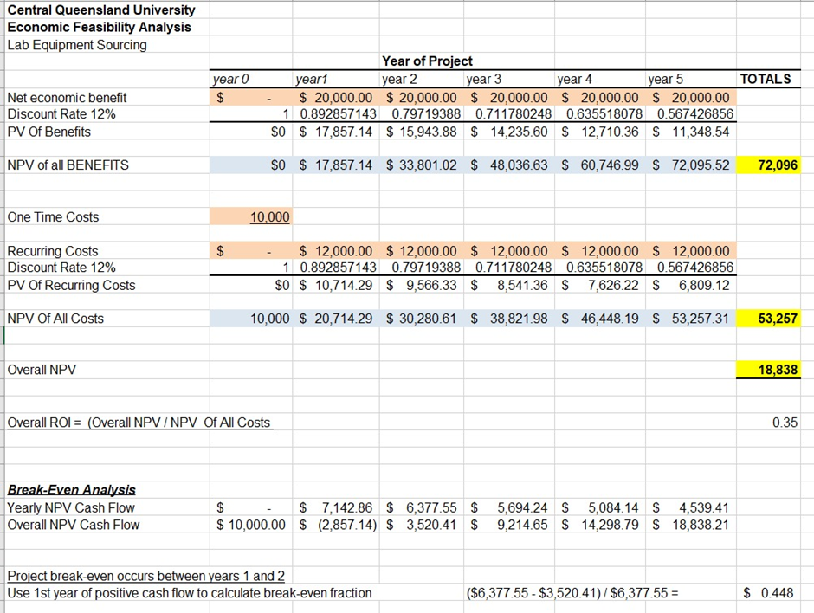

Fig: Cost benefit analysis table

## 3.2 Technical feasibility

1. We don’t need a specified training for the users to make understanding of the application.
2. The application will be developed to support both android and IOS.
3. The user – interface will be more attractive and easier to use. We can access the application through online from anywhere in this world.
4. The data visualization helps to generate the reports, where we can address the data at faster rate.
5. On technical point of view, the application is like inventory tracking and management. There won’t be any constrains or difficulty to proceed further.
6. It needs some necessary tools to make product much productive.
7. The Java programming language is the better option to carry out the application. As it has a key feature like object oriented, platform independent etc. This will support to make application much more effective.

## 3.3 Operational feasibility

1. The data integration supports application which makes it more consistent in real world
2. The dedicated resource is needed to maintain and update the data at period.

## 3.4 Legal feasibility

The data can be reused only for business purpose once it is approved from the actual users. As per the requirement, the app will not go through any illegal activities.

The data of the staff and students will be stored in separate database for better privacy.

# Link for GitHub and Jira

Me and my group members have created the code repository for Lap equipment sourcing application. The management tool will help us to keep track and helps to manage the quality of the application.

The link for GitHub is: <https://github.com/Java8520/Lab-Equipment-sourcing>

And we have also created the profile of Lab equipment sourcing in Jira for agile development process. We have linked each and everyone of our team and also invited our subject supervisor to monitor the process. The link for Jira is:

[LES board - Agile board - Jira (atlassian.net)](https://adarsha-lamichhane.atlassian.net/jira/software/projects/LES/boards/1)

# Requirement Specification

## 4.1 Functional Requirements

The functional requirement of the system of system are:

* Application will need two different login pages
* Admin will be able to add and delete the student details
* Admin will also need an authorisation to access the application
* The application will need to recommend automatically

## 4.2 Non-functional requirement

* Performance: The application must handle any expected and unexpected errors. The performance of the application should be fast enough.
* Security: User must need unique identifications ID to login in the system and only the admin will have access to add and delete the student details.
* Capacity: The application should be able to store huge amount of data and information
* Reliability
* Efficiency

# Software Architecture

The CQU lab management system will be developed in the single tier architecture that means that all the 3 layers that is presentation, logical and data layers will be tightly connected, and all code will keep on single machine. This will also enable high security.

To understand in a very simple ways, single tier architecture has components as presentation logic, business logic and data access logic. Presentation logic where the tasks are translated to something that user can understand and logic tier coordinated the application, process commands and makes logical decision and performs calculation. Logic tier also moves and process the data between the surrounding layers. However, data access tier stores the data and information and retrieved its from the database and passed back to the logic tier so that logic tier can then process it.

N-tier is very easy to use because the application is divided into independent tiers, one can easily reuse each tier for other software projects (Alvatar,2017). N-tier is very simple and friendly for the development so that different team members can work in different tiers.

Figure 1 : N -tier Architecture

# Layer Modelling

CQU lab Management system will follow Model View presenter pattern (MVP). The MVC pattern divides an application into three parts and they are:

* Model

The model is a set of classes that illustrates business logic and data information.

* View

View is the component which directly interact with user like Activity, Fragments.

* Presenter

Presenter receives the input form users and process the user’s data with the help of model and passes the data results back to the view. The presenter manipulates the model and also updates the view (Sinhal,A. 2017).

Figure 2 MVP pattern

# Database Design

Database design starts with a conceptual data model and produces specification of a logical schema (Watt, 2014). The main objective of database design is to produce logical and physical design models of the database system. The database design will then decide how and what data must be stored in the system. Here is the design documentation of the CQU lab Equipment Sourcing system:

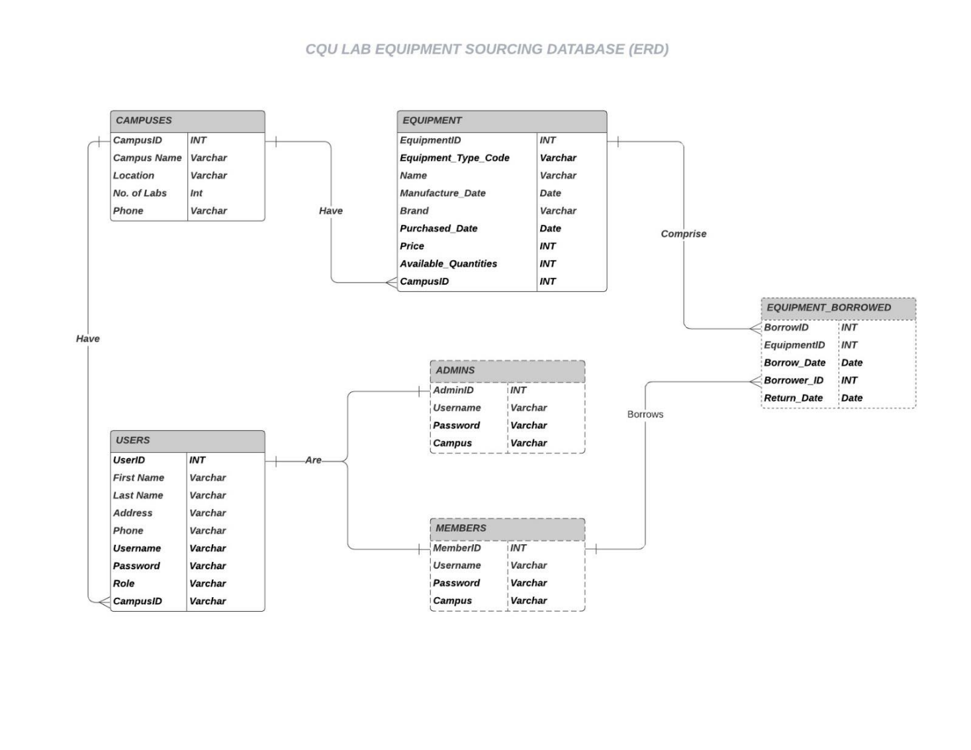

Figure : Database Design ERD

# Process flow diagram (Lab Members End)

Project flow diagram is a flowchart used to illustrate high level processes. Below you can see the flow chart diagram of Lab Equipment Sourcing software through Members End:

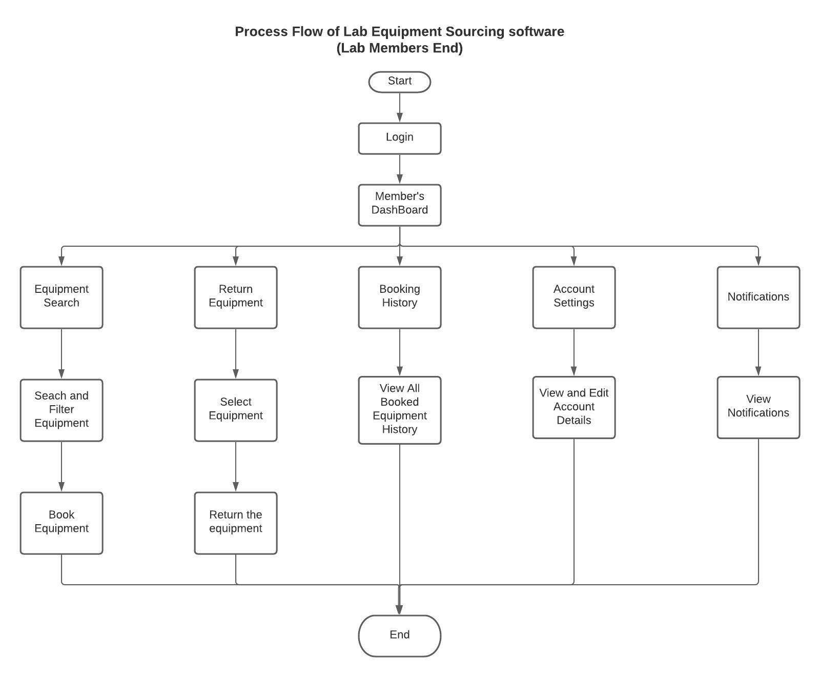

Figure 4 : Process flow (Member’s End)

# Process flow at admin’s end

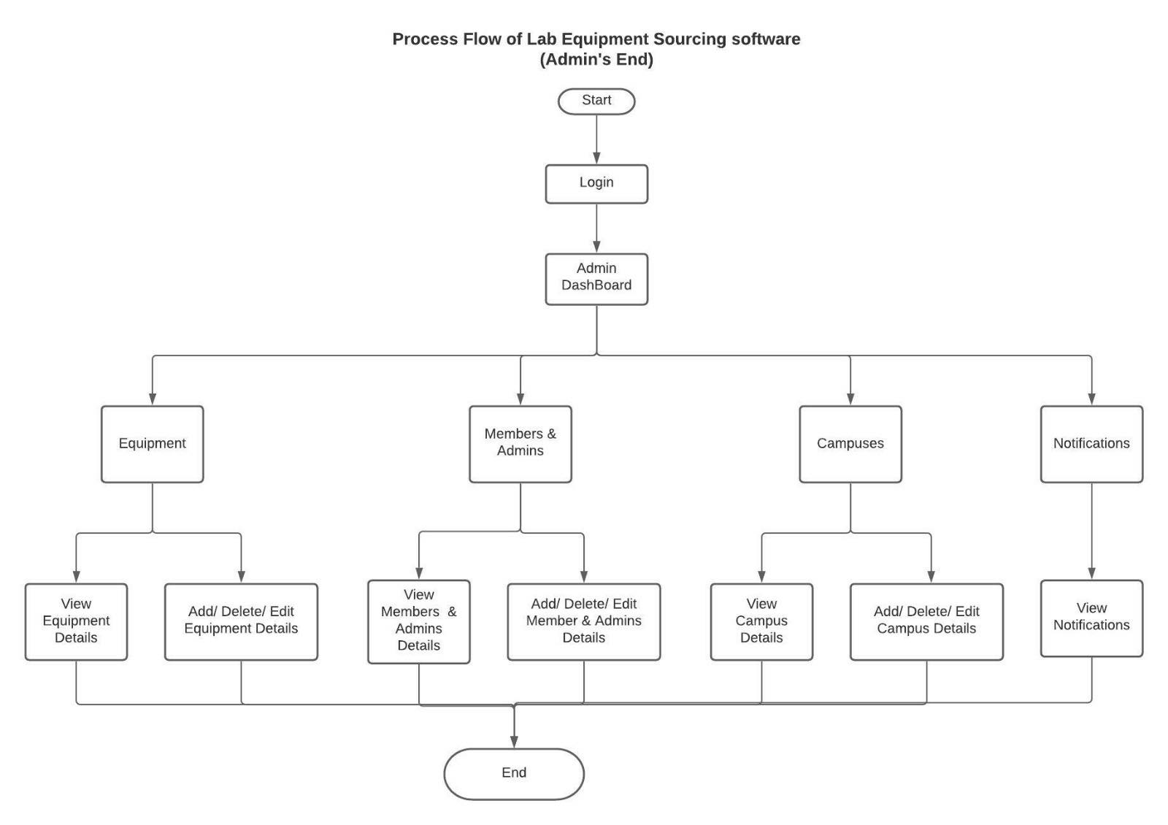

Figure 5 : Process flow (Admin's End)

# UML Use case diagram

Use case diagram describes the high-level functions and the scope system. Use case diagram model describes the behaviour of the system and helps to capture all the requirements of the application. The figure below shows the Use case diagram of the Lab Equipment System:

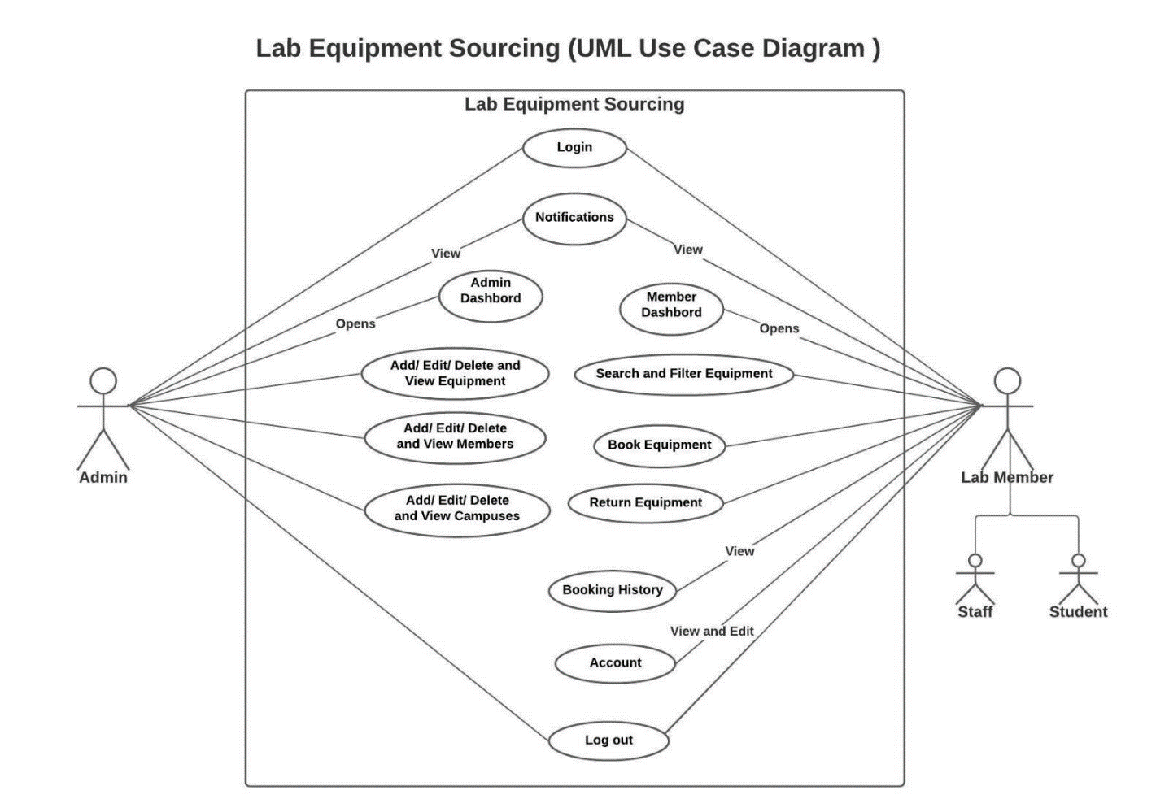

Figure 6 : Use Case Diagram

# Class Diagram of Lab equipment sourcing system.

Class diagrams are the building blocks in the object-oriented language. Class diagrams are used to show the different entities and attributes of the system.

Classes in the class diagram are represented in the box, the top part contains the name of the class whereas the middle part contains attributes, and the last bottom part represents the operations which are associated with the class.

The following figures is a class diagram of lab equipment sourcing system:

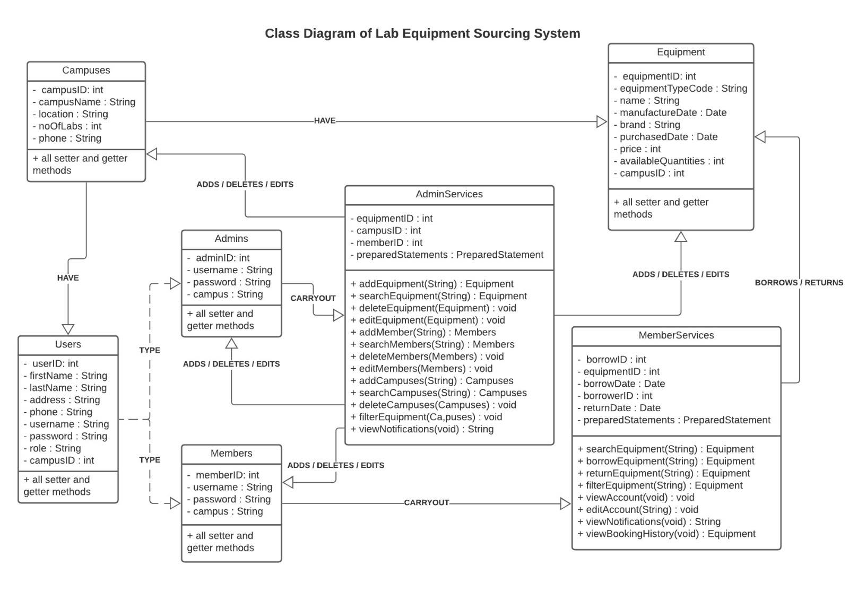

Figure 7: Class Diagram

# Sequential diagram

Sequence diagram is defined by the UML manual as “a diagram that shows object interactions arranged in time sequence” (Baqais and Alshayeb, 2018). Sequence diagram is a UML diagram which illustrates the sequence of the message between the objects. Sequence diagram helps to understand the relation between the objects. Figure below shows the interaction of admin(actor) and the layer entities:

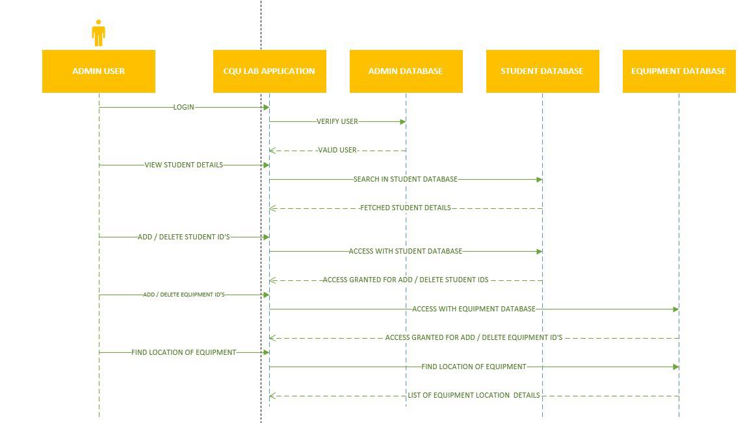

Figure 8: Sequence diagram (admin)

Above diagram shows the interaction between admin and the layer entities. The admin logins to the CQU application. In the homepage we can see admin logins with their credentials authentication and only admin can view staff and student details and can add, delete staffs and students.

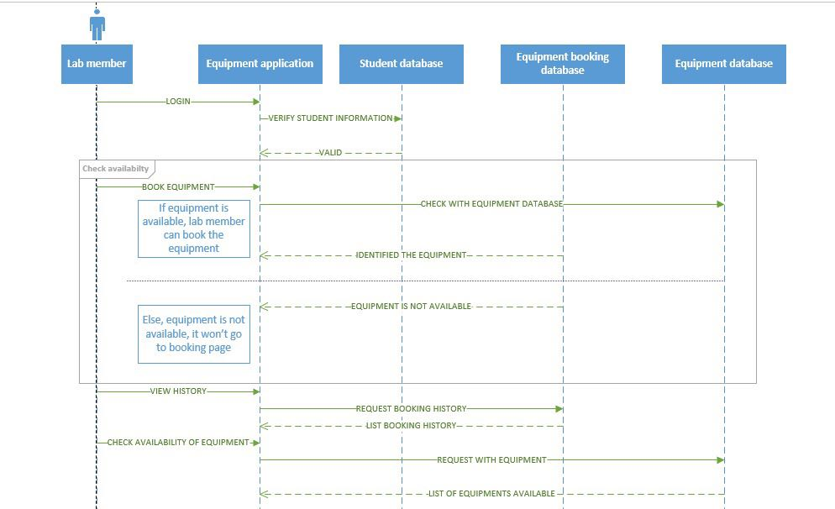

Figure 9: Sequence diagram (Lab members)

Here in the above diagram, we can see the interaction between the lab members and the layers. In the homepage we can see that the lab members logins with there credentials and if that is valid then the lab members can use rest of the function like booking equipment and checking the availability of the equipment.

# WHAT IS RISK MANAGEMENT?

The risk management is important for any project which we are going through. The risk management is nothing but, identifying the problem before it gets impacted in the project.

The project manager or BA must take up the role to analyse the risk in this project for all the possibilities. The main objective of the risk management is to identify the proper solutions for the list of risks analysed by project manager and BA. In this project “Lab Equipment Sourcing”, The PM and BA identified the list of risks which may affect the project in various aspects. It might be the serious thread to time management, scheduling and even in the quality of the software product. Those risks need to be mitigated from various solutions.

P – It stands for the occurrence of risk

I – It stands for the percentage of impact which may rise in the project.

J - P* I J stands for Jeopardy of the project.

# LIST OF RISKS INVOLVED IN THIS PROJECT

|  |  |  |  |  |  |
| --- | --- | --- | --- | --- | --- |
| S.NO | Risk | P | I | P*I | Solution / Mitigation |
| 01 | Requirement changes frequently by client side | 6 | 7 | 42 | The project manager has to understand the initial stage of the document, Identify the queries. Have the meeting with the project owner frequently to get clear idea about their requirement before the initiation of work. |
| 02 | Data Integration | 5 | 3 | 15 | In this project “*Lab equipment sourcing”* it is important to maintain the proper datasets. There are various tools to integrate the multiple datasets. By using those tools, it is easy to mitigate those risks. |
| 03 | Communication problem between team members | 8 | 7 | 56 | It is the serious threat, where it may create serious impact to the project. It is mandatory to have internal discussion with their team members in daily basis. Updating their work in separate portal where every team member in the group can view their workings. It needs to be rectified at the initial stage itself. |
| 04 | Task need to be spitted equally | 7 | 7 | 49 | First stage of reducing those risks by analysing the skillsets of each team member in the group. Based on their understandings and skillsets, tasks need to be listed and shared equally within their group. |
| 05 | Data tracking | 6 | 5 | 30 | If the team members are updating their work in different DB, it creates difficulty in tracking those datasets. To overcome this issue, Centralized is the only option where helps to have access to all the other members in their group. |
| 06 | Lack of Expertise | 5 | 5 | 25 | If the user doesn’t have enough knowledge in handling the application, it may create the risks in multiple ways. To avoid this situation, The PM or other people who have involved in the project has to give KT (Knowledge Transfer) to the users of the application. |
| 07 | Upgrade platform | 4 | 3 | 12 | The application needs to update frequently, it may help to reduce some risks. Currently, the application is running as standalone. But it could be better to have cloud-based application to increase the performance of the system. |
| 08 | Team coordination | 6 | 7 | 42 | If there is any lang in team coordination, it will create the serious damage to the quality of the product. To overcome this issue, team building activities are helps to resolve those risks. |
| 09 | Inventory maintenance | 5 | 4 | 20 | The equipment needs to be checked frequently; it has a chance of getting damaged. The quality of each equipment has to be checked and update at some interval of time. |

# Risk estimation on the project

Various risk may occur during the project development lifecycle; risk cannot be avoided but the impact of such risks can be vastly reduced with the help of project plan Therefore, the risk that may occur in the project are clearly identified with its occurrence and impact. Some of the risk that can occur in the discussed project are given below with their probability, impact on the project, threats caused by it on the project and mitigation strategy to reduce the impact of such risks.

All businesses face risk. It's important to understand the risks to your business and find ways to minimize them. A risk management plan helps us to do this by detailing how we deal with risks to our business. By spending time and resources developing our strategy for managing risk, we’ll provide a safe workplace and reduce the chances of negative impacts on your business. Project risk can be defined as the uncertainty present in project due to various factor which affect all the stakeholders involved in the project as well as the whole project which may generate different outcome both positive and negative in the project. When you’re planning your project, risks are still uncertain: they haven’t happened yet. But eventually, some of the risks that we plan for do happen, and that’s when we must deal with them. There are four basic ways to handle a risk.

1. Avoid: The best thing you can do with a risk is avoid it. If you can prevent it from happening, it won’t hurt your project. The easiest way to avoid this risk is to walk away from the cliff, but that may not be an option on this project.
2. Mitigate: If you can’t avoid the risk, you can mitigate it. This means taking some sort of action that will cause it to do as little damage to your project as possible.
3. Transfer: One effective way to deal with a risk is to pay someone else to accept it for you. The most common way to do this is to buy insurance.
4. Accept: When you can’t avoid, mitigate, or transfer a risk, then you must accept it. But even when you accept a risk, at least you’ve looked at the alternatives and you know what will happen if it occurs. If you can’t avoid the risk, and there’s nothing you can do to reduce its impact, then accepting it is your only choice.

Table 5: Risk estimation of the project

|  |  |  |
| --- | --- | --- |
| Number | Risk | Mitigation Strategy |
| 1 | Meeting between the team and the project owner | Due to the current situation of pandemic, the table talk meeting between the team and the project owner is not done properly. Therefore, an online zoom session was introduced where the group members and the tutor came online in the same time to discuss regarding the project. |
| 2 | Requirement not understood | The functional and non-functional requirement of the system must be collected and must be understood by all the team members, since the project are developed on such requirements, it is vital to understand the project requirement. Zoom session, online group discussions etc. can be used to clear the misunderstanding on the project requirement. |
| 3 | Requirement changes by the client. | Changes can occur in any point of the development lifecycle, as a client he/she can change the requirement of the project after some time. Therefore, the meeting between the client and the team is essential in any project development. This can be done by the help of emails, online group discussions, ZOOM sessions etc. |
| 4 | Overload of work on single member of the team. | Each team member has their own strength and weakness, the tasks are divided in terms of the team member strengths. Such division can be pressuring the individual therefore, the task division should be done which doesn’t overload the workload of the individual in the team. |
| 5 | Conflict while merging the files | The project is done in group where the team members are responsible for the tasks divided by the team leader. Merging the files from all the members can be a hassle which may arise some conflict on the version of the files. To mitigate this risk, version control system can be used. |
| 6 | Data loss | Data loss can jeopardize the whole project, it should not be taken lightly since data can be lost due to various reasons. Therefore, the version control system is used and the backup of the updated project in different systems of team member is done. |
| 7 | Team Skills | Each team member has their own strength and weakness if certain team member is weak in certain field of project development. Learning these skills from various method such as studying books, doing research, watching tutorial videos, consulting other professionals, etc. need to be done by the team members to strengthen their weakness. |
| 8 | Technical difficulty | Even with the skills present in the team, certain technical difficulty may impact the overall development of the project. Therefore, consultation with different IT experts and tutor can be done to mitigate this risk. |

# USER STORIES

## As an admin

* I can login into the system
* I can add new student ID’s
* I can delete and edit the existing student details
* I can add equipment details (Name, ID, Location)
* I can delete and edit the existing equipment details
* I can view list of student details
* I can view list of equipment details
* I can add/Delete campus details
* I can track the student history
* I can see student details individually
* I can logout of the system

## As a student

* I can login into the system
* I can view the list equipment in the laboratory
* I can search the equipment as per my work
* I can book the equipment
* I can view the history of my own
* I can see the due date of the equipment which I borrowed from the laboratory
* I have an option to withdraw my equipment before the due date
* I can logout of the system

## Prioritizing the User stories

* Create two different dashboards for admin and student in our application.
* Create UI design for each page.
* Create the booking system for students, it is one of the important requirements from the client side.
* Create table for students and equipment where it could be useful for two users (students and Admin) for add, delete, edit, view.
* Create search option to check with equipment’s availability
* Create tracking system to view the history of students who have borrowed from laboratory
* Create withdraw option for students to return equipment before the due date.
* Create search option to view student details inclusive of history, recently borrowed from laboratory.

# Quality Management Plan

The quality management plan is the necessary document required to manage the quality of the project effectively. Quality management is the process of planning, scoping, implementing, and monitoring of quality into all phases of the project from concept through the delivery aspects of the work (Patterson, 2019). In short, we can say that project quality management plan documents are a necessary document required for effective management of the project from planning to delivery.

The project quality plan is prepared during the planning phase of the project. Quality management involves planning, managing team, skill forming and other project planning things. The intended audience are the project manager, project teams, senior leaders, and stakeholders. There are so many tools associated with quality management plan some of them are:

1. Quality Planning:

In quality planning the project manager codifies the standard of project and work on those standards to achieve the goal of the project.

1. Quality Assurance:

Quality Assurance begins with the planning, designing, engineering. The quality which has been planned in the quality planning are implemented.

1. Quality Control:

After all of planning and assurance, quality control is the last process under quality management. Things like monitoring the project metrics is done in this phase.

# Quality roles and responsibilities

|  |  |  |
| --- | --- | --- |
| Name | Role | Quality responsibility |
| Dr. Zakiullah Khan | Client Representative | Quality Audit |
| CQU University | Project Owner | Quality Coaching and testing |
| Adarsha Mani Lamichhane  Bandana Kapali  Javagal Srinath Narayan  Maruf Siddique | Software Developers and testers | Functional testing and quality assurance analyst |
| Jamie Shield | Course Coordinator | Quality Audit |

## Quality Metrics

|  |  |  |  |
| --- | --- | --- | --- |
| Metric | Standard | Measuring Method | Quality Criteria |
| User Friendly | The application needs to be user-friendly and should be easy to use. The application is flexible to use so user of any ages will be able to use the software. | Testing | The application should be user friendly and should run in any devices. |
| Cost of maintenance | The cost maintenance should be minimum | Auditing | The maintenance cost should be minimum that means all the cost of spreadsheet and paperwork should minimize. |
| Implication of the new technology | New tools and technology need to be use when necessary | Auditing | The tools and technology need to be up to date, and the framework must follow the MVP modelling. |
| Functionality | All the functional required that has been discussed should be implemented | Testing | No error must be found |
| GUI | The user interface needs to be simple, so any user can use it. | Testing and auditing | The GUI must be simple and attractive to the user. The colour combination should be simple and photoshop or any other tools must be used if necessary. |
| Performance | The performance of the application should be fast, and no latency should encounter during and tasks. | Testing | The vast data and files should be minimise to avoid latency. |

# Interface Prototype

**1. LOGIN SCREEN**

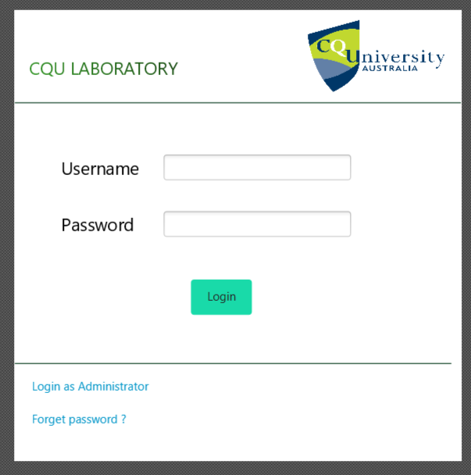

Figure 10 Login screen

**2. STUDENT DASHBOARD**

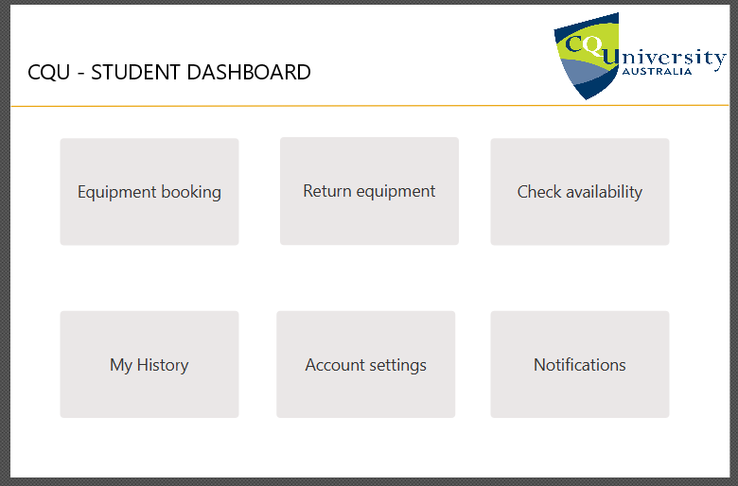

Figure 11 : Student Dashboard

**3. ADMIN DASHBOARD**

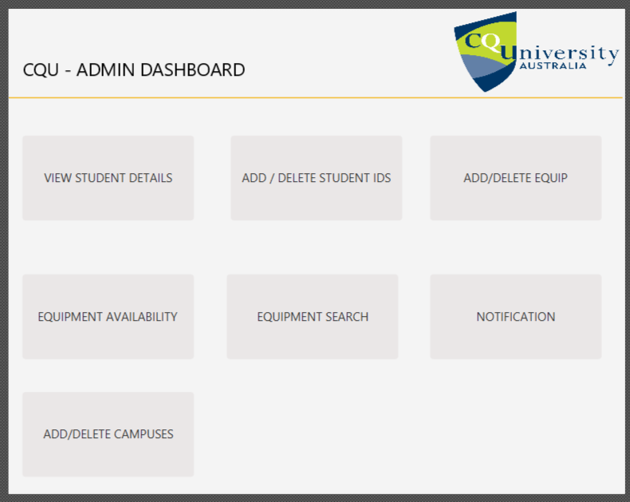

Figure 12 : Admin Dashboard

**4. EQUIPMENT SEARCH WINDOW – PROTOTYPE DESIGN**

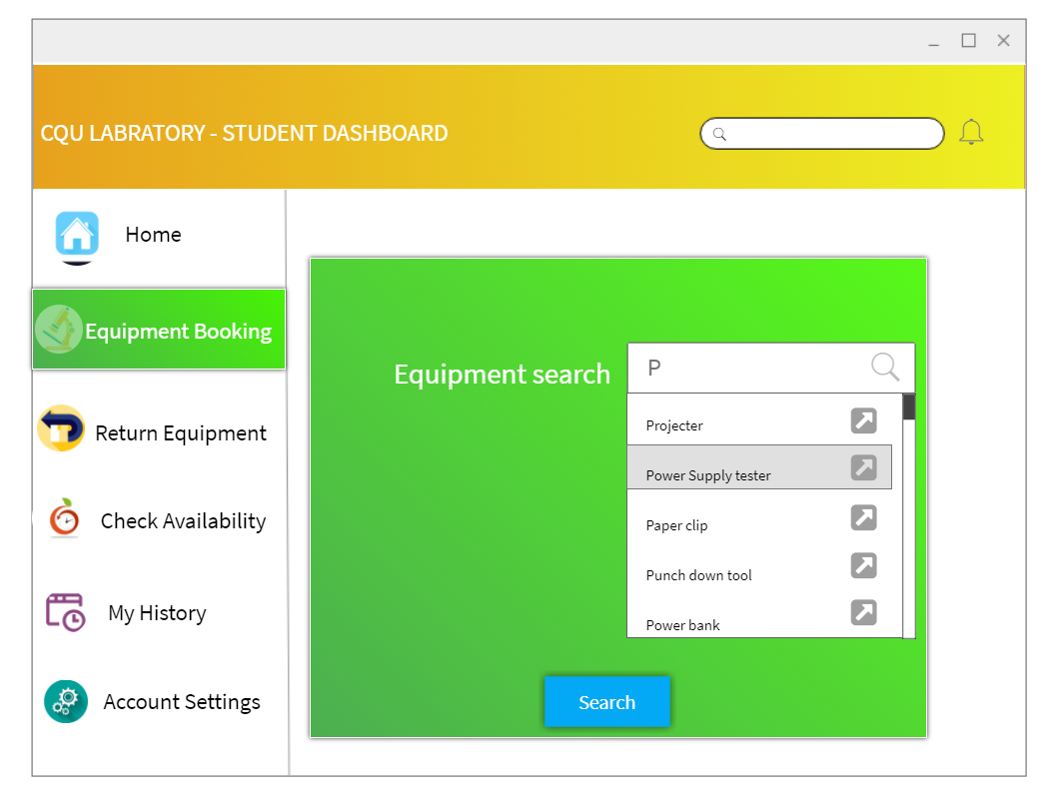

Figure 13 : Search window

**5. MY HISTORY**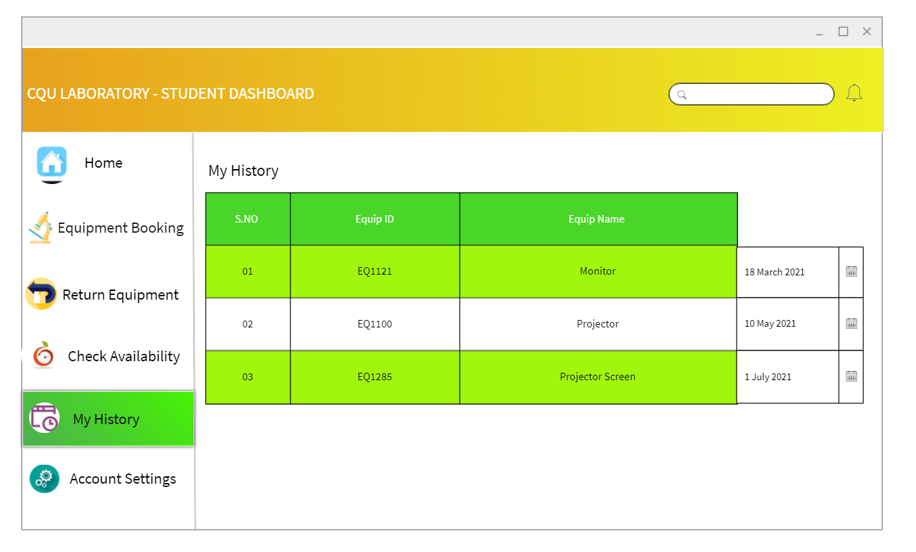

Figure 14: History Page

**6. MY SETTINGS**

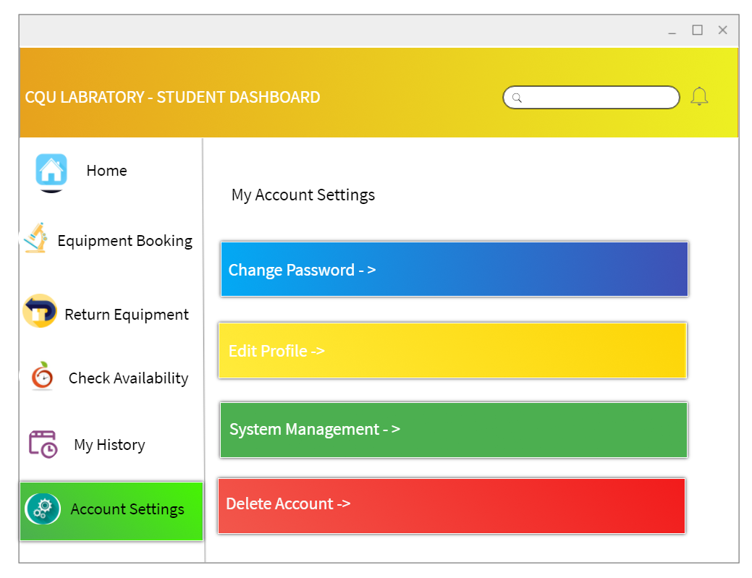

Figure 15 : My settings

**7. CHECK AVAILABILITY**

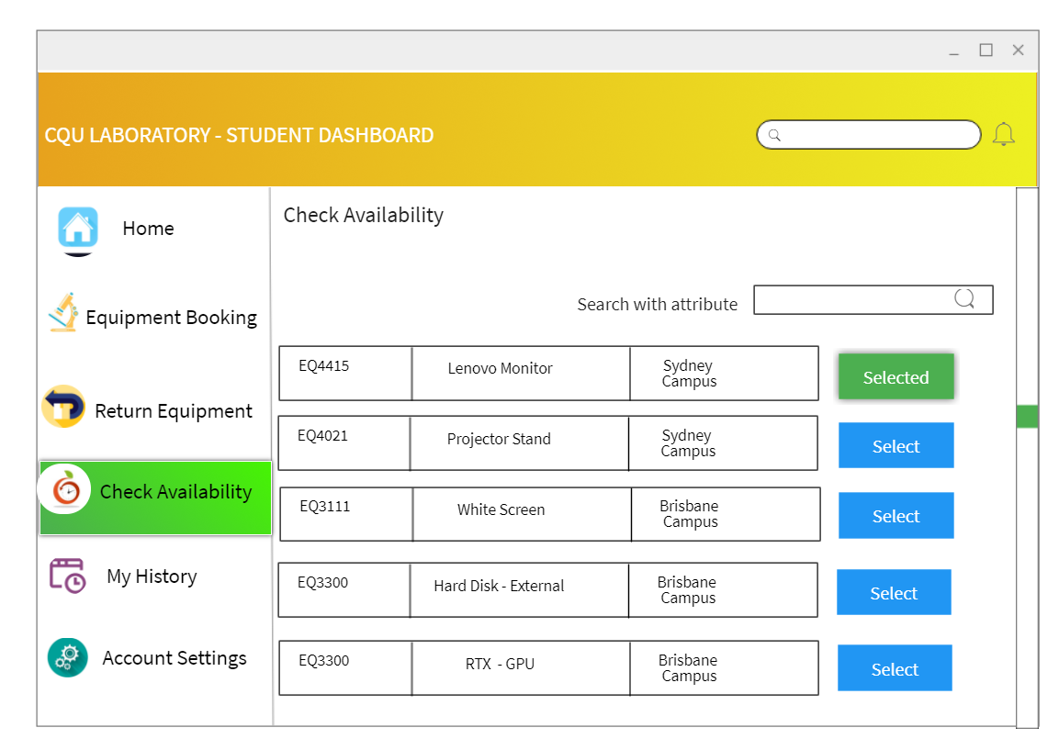

Figure 16 Student dashboard

**8. RETURN EQUIPMENT**

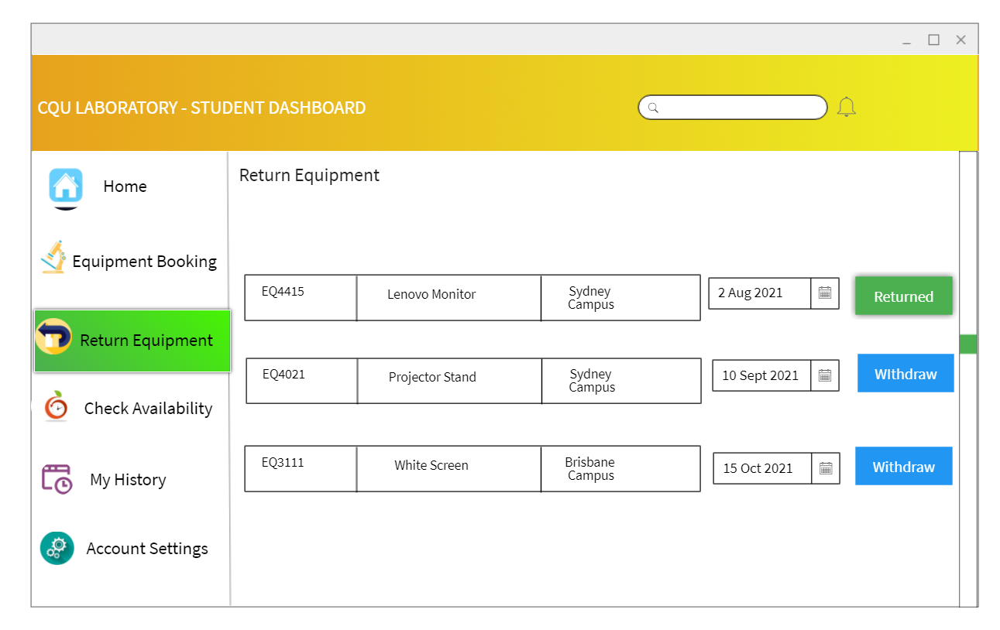

Figure 17 : Student Dashboard

**ADMIN DASHBOARDS**

**1. STUDENT SEARCH**

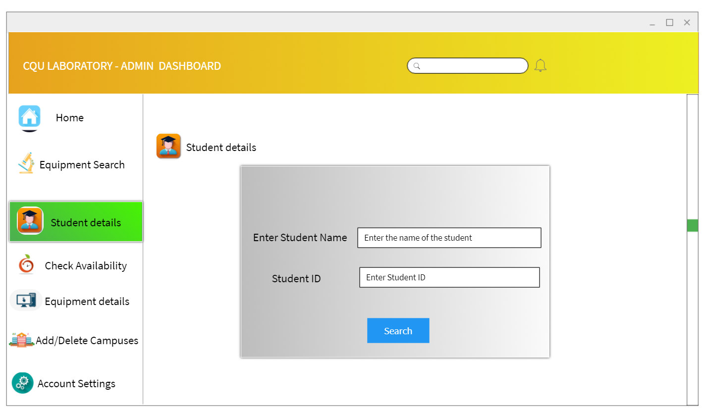

Figure 18 : Admin Dashboard, Student Search

**2. STUDENT DETAILS – ADD / DELETE**

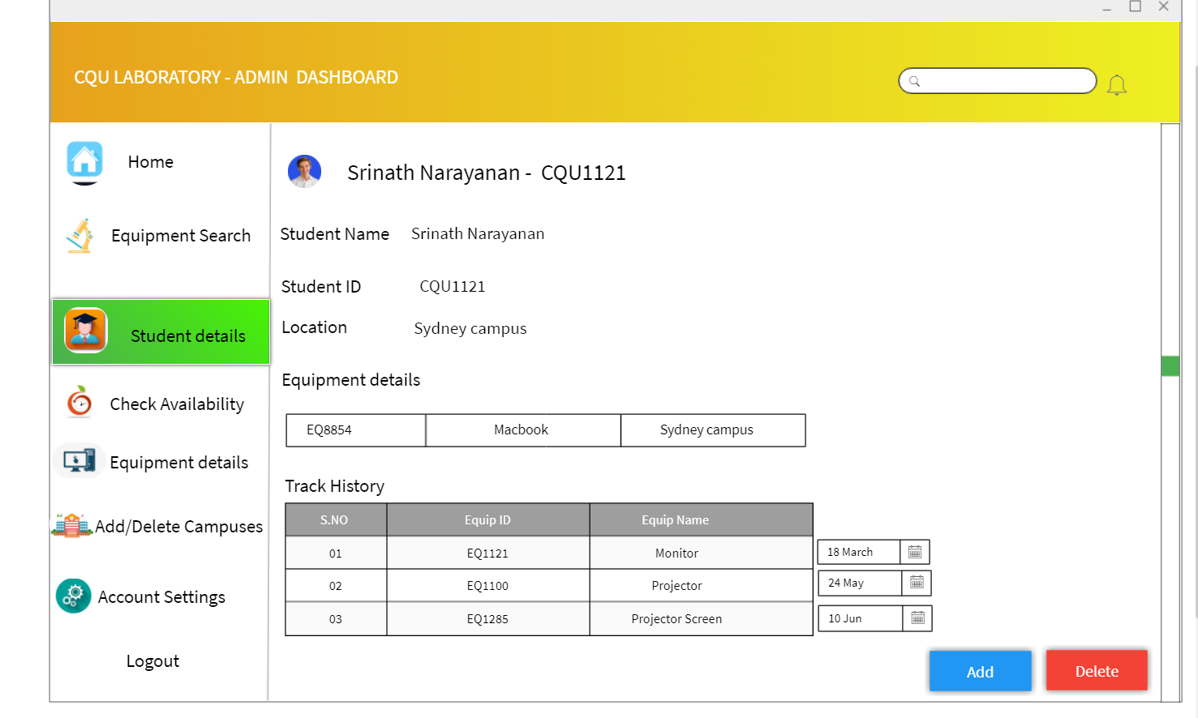

Figure 19 Add or delete student page

**3. EQUIPMENT DETAILS - ADD / DELETE**

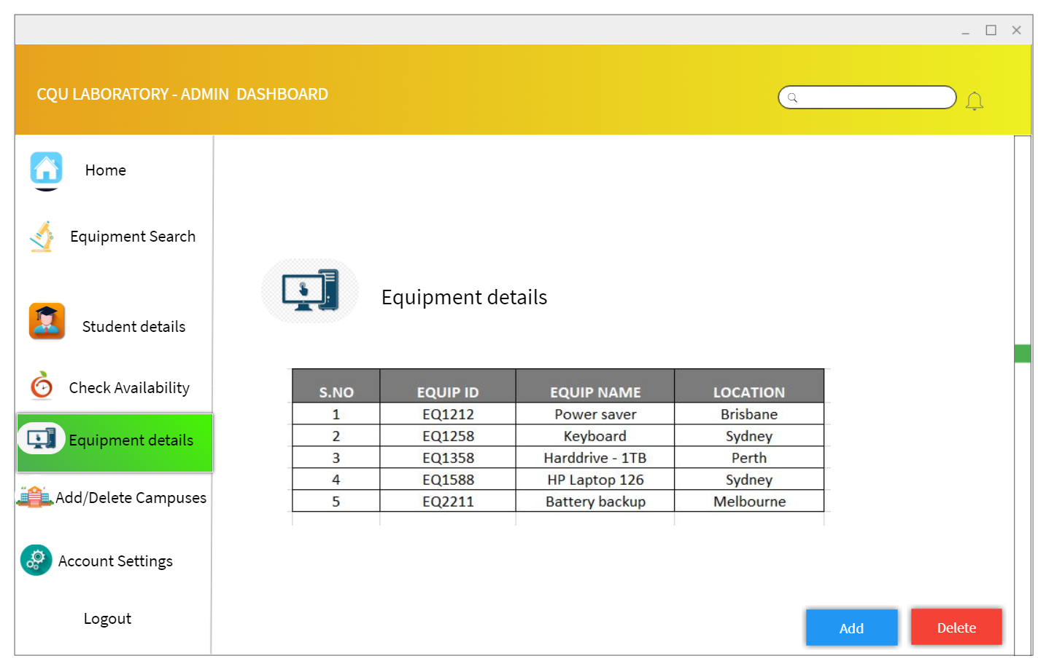

Figure 20 : Equipment details

**4. CAMPUS DETAILS – ADD / DELETE**

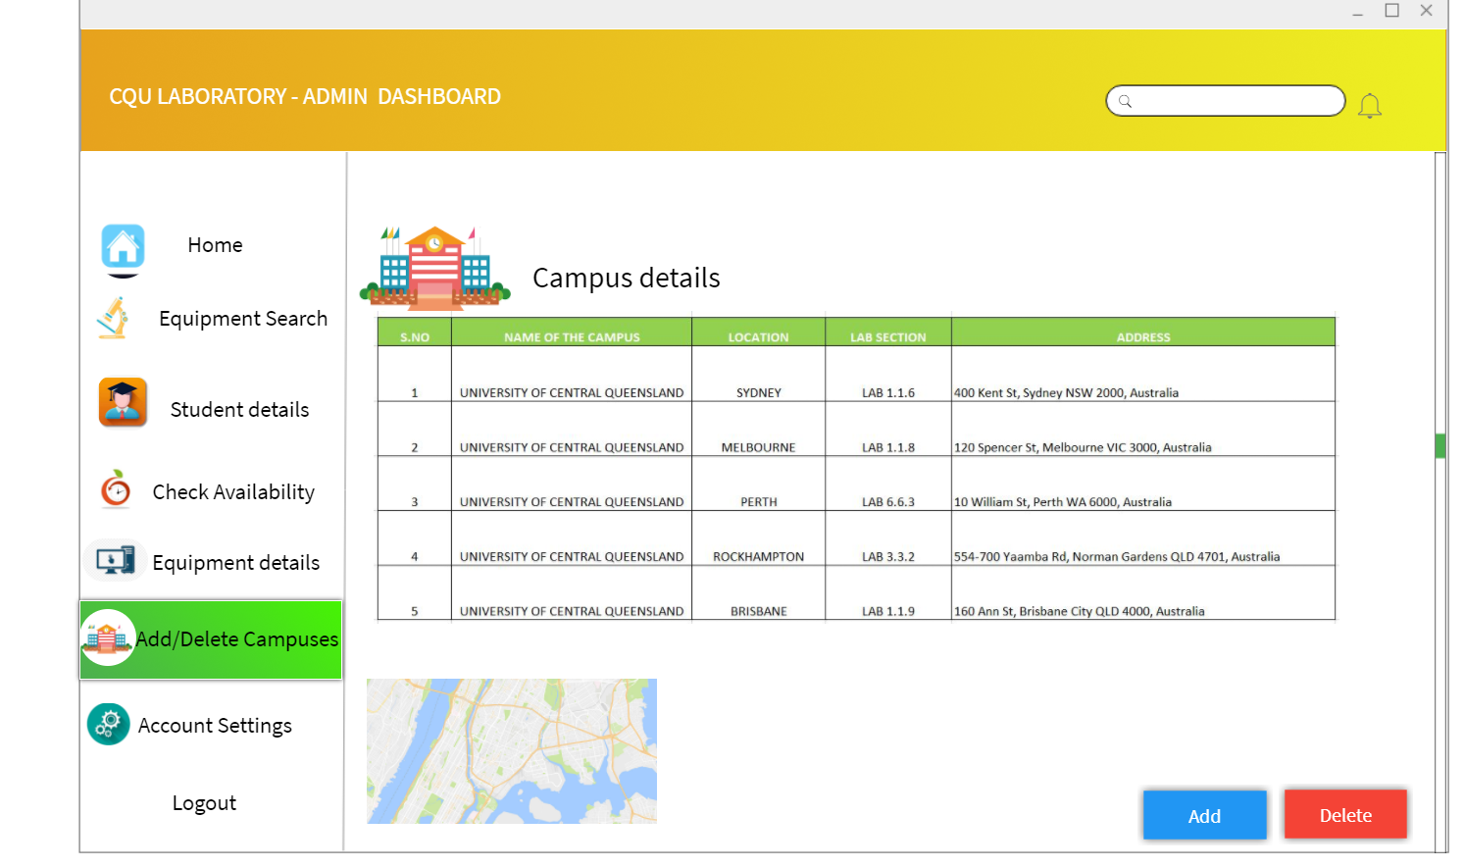

Figure 21 : Campus Details

# Implementation of User Stories

**User Story:**

1. The system actors need to be able to access their own services assigned to them according to their role.

**Implementation of the user story:**

* The system actors are divided mainly into Admins and Members.
* A single login page appears at first when the system is started.
* According to their individual login credentials, they are identified as admins or members of the system.
* If the user is Admin of the Lab System, he is redirected to the admin dashboard where all the services assigned to an administrator is displayed and he will be able to access them all.
* If the user is Member of the Lab System, he is redirected to the Member dashboard where all the services assigned to a member is displayed and he will be able to access them all.

**Test of the user story implementation:**

|  |  |  |  |  |  |
| --- | --- | --- | --- | --- | --- |
| Test No. | Test Name | Input | Expected Output | Actual Output | Remarks |
|  | Login Portal Check  (For Admin Login) | * Username: **admin** * Password: **admin1** * **Login** Button Clicked | Admin Dashboard needs to be displayed. | Admin Dashboard was displayed. | **PASSED** |
|  | Login Portal Check  (For Member Login) | * Username: **student** * Password: **student1** * **Login** Button Clicked | Member Dashboard needs to be displayed. | Member Dashboard was displayed. | **PASSED** |

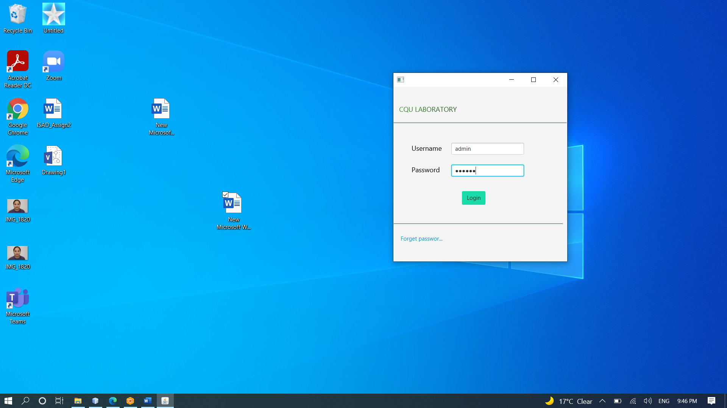

Figure 1 Admin Logging in from Login Page



Figure 2 Admin Dashboard displayed after Admin Logged In

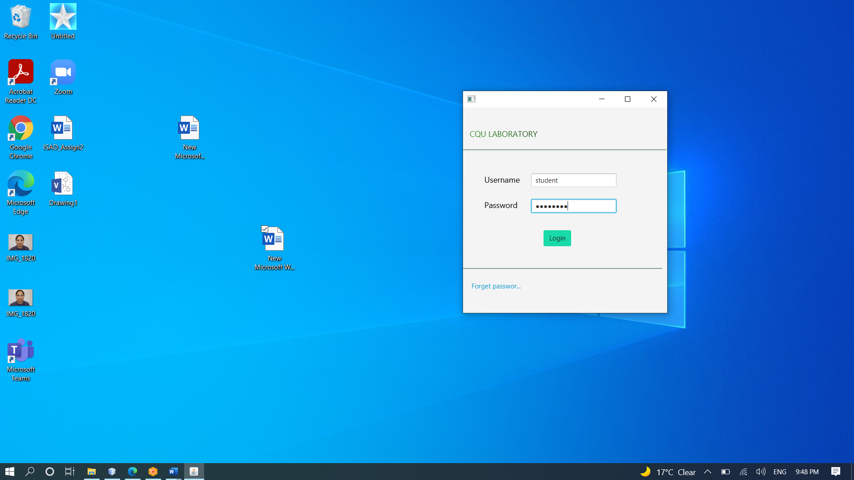

Figure 3 Member Logging in from Login Page



Figure 4 Member Dashboard displayed after Member Logged In

## User Story:

1. Admin will be able to add, edit, delete, search and view the campuses, admins, students and lab equipment.

## Implementation of the user story:

* Once admin logs in from the login page, he enters the Admin Dashboard.
* He can see all the accessible services on the dashboard itself and can choose to enter into any of them by clicking on the corresponding button.
* Admin has the full CRUD authority to carry out on all the models of the system. The models are Admins, Campuses, Lab Equipment, and Students.
* Upon clicking each button to access a service, the system will redirect the Administrator to a new page where he can either add, search, view, edit or delete the elements of the system.

**Test of the user story implementation:**

|  |  |  |  |  |  |
| --- | --- | --- | --- | --- | --- |
| Test No. | Test Name | Input | Expected Output | Actual Output | Remarks |
| ADMIN DASHBOARD PAGE | | | | | |
| 1 | ADD ADMIN BUTTON | * Clicked Add Admin Button | A new window to add a new admin will be displayed. | A new window to add a new admin was displayed. | **PASSED** |
| 2 | ADD STUDENT BUTTON | * Clicked Add Student Button | A new window to add a new Student will be displayed. | A new window to add a new Student was displayed. | **PASSED** |
| 3 | ADD STUDENT BUTTON | * Clicked Add Equipment Button | A new window to add a new equipment will be displayed. | A new window to add a new equipment was displayed. | **PASSED** |
| 4 | ADD CAMPUSES BUTTON | * Clicked Add Campuses Button | A new window to add a new campus will be displayed. | A new window to add a new Campus was displayed. | **PASSED** |
| 5 | STUDENT DETAILS BUTTON | * Clicked Student Details Button | A new window to search the student will be displayed. | A new window to search the student was displayed. | **PASSED** |
| 6 | EQUIPMENT DETAILS BUTTON | * Clicked Equipment Details Button | A new window to search the equipment will be displayed. | A new window to search the equipment was displayed. | **PASSED** |
| 7 | LOG OUT BUTTON | * Clicked Log Out Button | Admin will return back to the login page. | Admin returns back to the login page. | **PASSED** |
| ADD ADMIN PAGE | | | | | |
| 8 | REGISTER NOW BUTTON | * Clicked Register Now Button | “New Admin Added” prompt will be displayed. | “New Admin Added” prompt was displayed. | **PASSED** |
| 9 | BACK TO HOME PAGE BUTTON | * Clicked Back to Home Page Button | Admin will return back to the admin dashboard. | Admin returns back to the admin dashboard. | **PASSED** |
| ADD STUDENT PAGE | | | | | |
| 10 | REGISTER NOW BUTTON | * Clicked Register Now Button | “New Student Added” prompt will be displayed. | “New Student Added” prompt was displayed. | **PASSED** |
| 11 | BACK TO HOME PAGE BUTTON | * Clicked Back to Home Page Button | Admin will return back to the admin dashboard. | Admin returns back to the admin dashboard. | **PASSED** |
| ADD CAMPUSES PAGE | | | | | |
| 12 | REGISTER NOW BUTTON | * Clicked Register Now Button | “New Campus Added” prompt will be displayed. | “New Campus Added” prompt was displayed. | **PASSED** |
| 13 | BACK TO HOME PAGE BUTTON | * Clicked Back to Home Page Button | Admin will return back to the admin dashboard. | Admin returns back to the admin dashboard. | **PASSED** |
| STUDENT DETAILS PAGE | | | | | |
| 14 | BACK TO HOME PAGE BUTTON | * Clicked Back to Home Page Button | Admin will return back to the admin dashboard. | Admin returns back to the admin dashboard. | **PASSED** |
| EQUIPMENT DETAILS PAGE | | | | | |
| 15 | BACK TO HOME PAGE BUTTON | * Clicked Back to Home Page Button | Admin will return back to the admin dashboard. | Admin returns back to the admin dashboard. | **PASSED** |

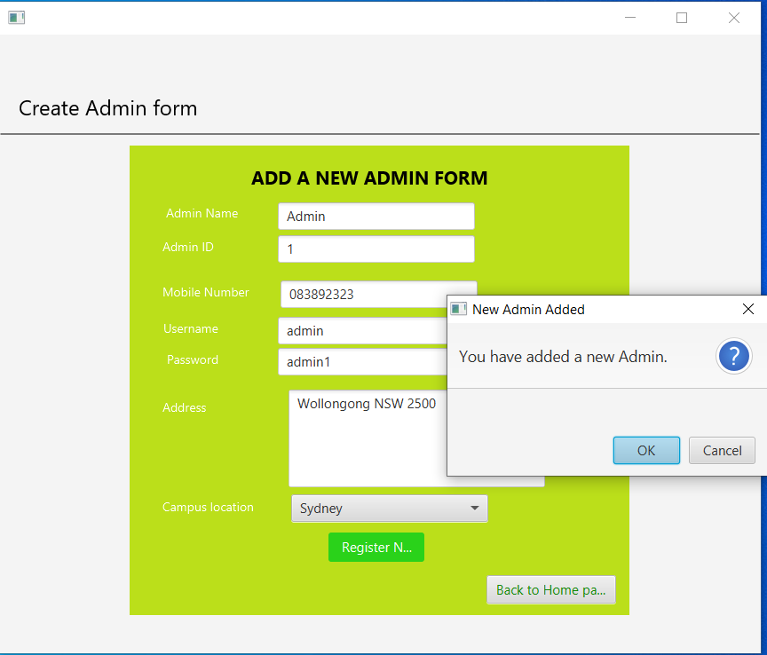

Figure 5 Add a New Admin Form page

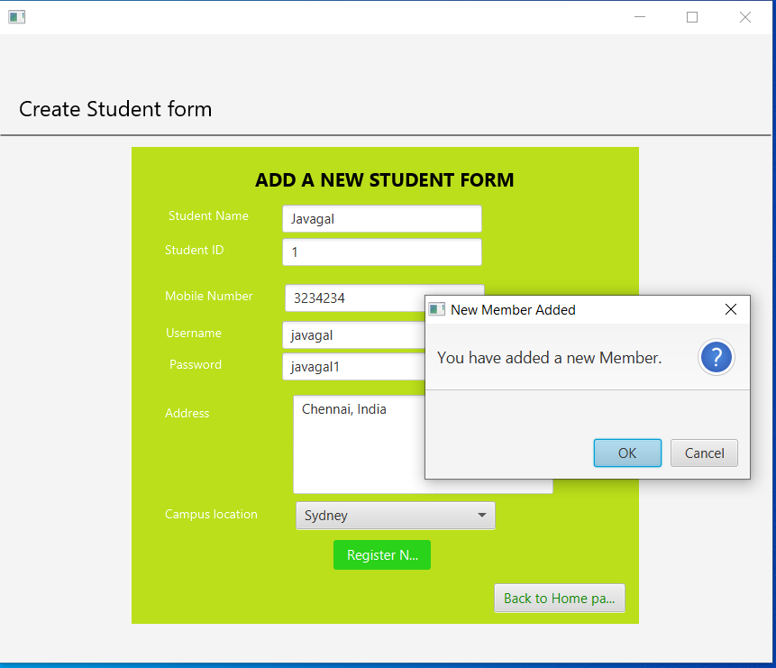

Figure 6 Add a new Student Form page

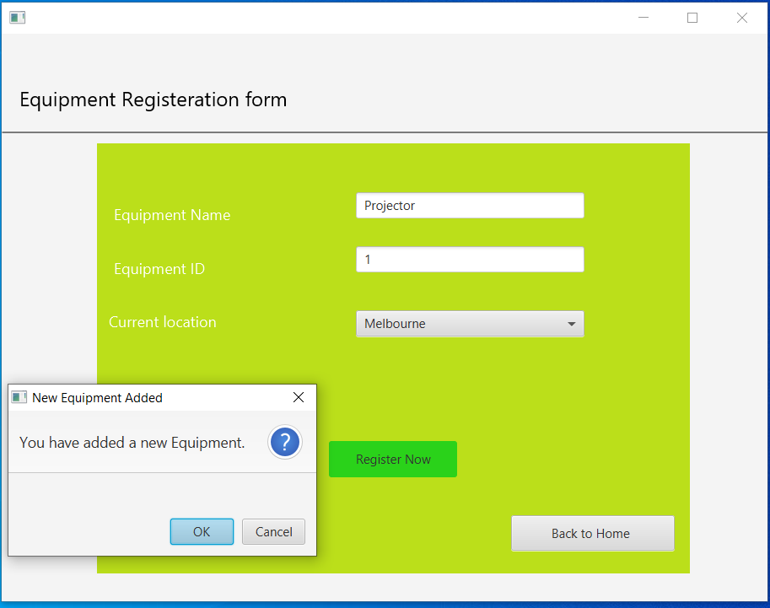

Figure 7 Equipment Registration Form page

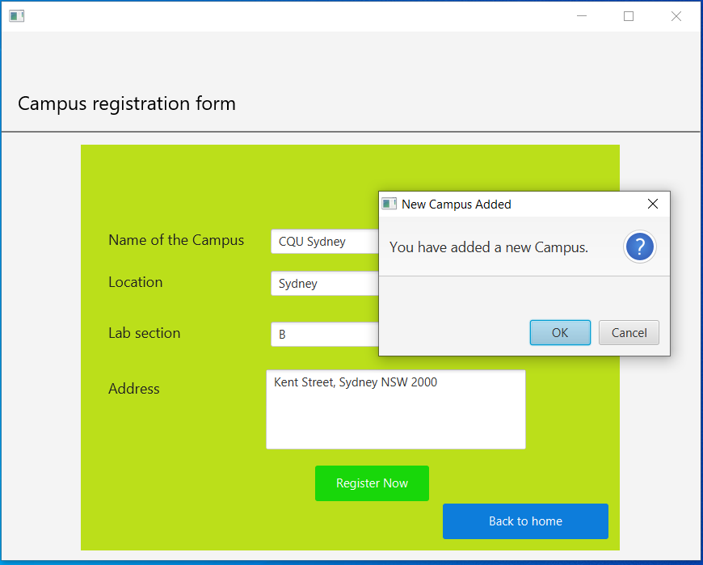

Figure 8 Campus Registration Form Page

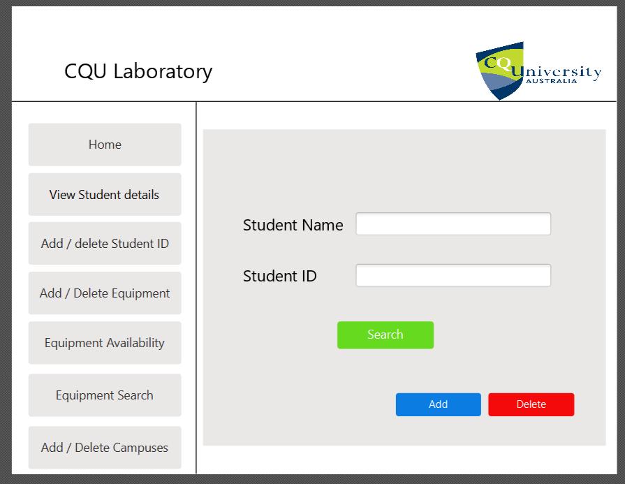

Figure 9 Student Details Page

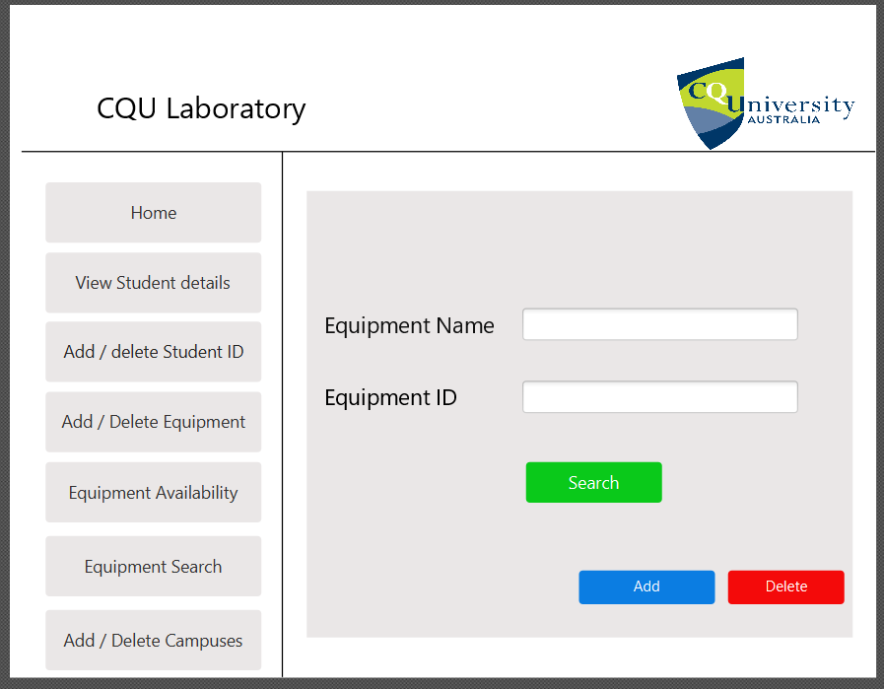

Figure 10 Equipment Search page